|  |  |
| --- | --- |
| **Title** | 1st homework in the C language class by 201923250 |

|  |  |  |  |
| --- | --- | --- | --- |
| **Author** | 201923250 | **Date** | 3.14.2021 |

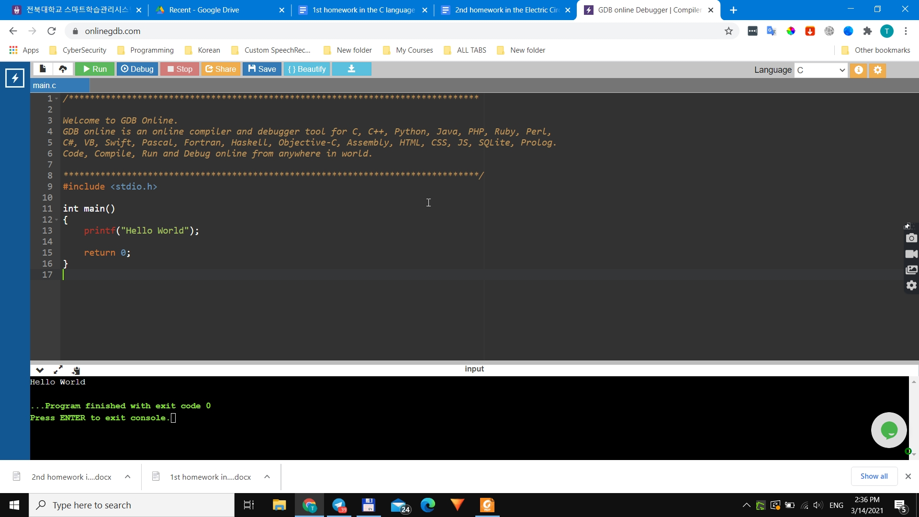

**Summarization for chapters 1 and 2**

C was initially used for system production, particularly for operating system composite programs. C may be written in one or more text file with extension ".c."

For example, Hello.c is an application that can stretch from 3 to millions lines. To write your C program into a format, you can select "vi," "vim," or any other text editor.

You have two tools available on your computer, (a) Text Editor and (b) C Compiler, to set up your C programming language environment.

**Installation of Visual Studio Community Edition**

I have an online platform to run C programs, due to the lack of storage I am not able to install Visual Studio community edition, I will be conducting all the examples and personal programs on this online platform.

The platform name is [https://www.onlinegdb.com](https://www.onlinegdb.com/)Thank you.